Software Requirement Specifications
Prakash S  prakash_sellamuthu@yahoo.in | Documentation Type: Software Requirement Spécification
 | Version No.: 1.0
Date of Release: 05 June 2014 |  | No. Of Pages : 14

“This document is confidential . The information contained herein is not to be revealed or disseminated outside to any other party without the prior expressed consent and written permission.

Revision History

Change Description | Section Numbers Changed | Version No. | Date of Revision | Revised By | Approving Authority
First release | All | 1.0 | 5-June-14 | Prakash.S

Table of contents

Error! No table of contents entries found.

LIST OF FIGURES

Figure 1 block diagram 3
Figure 2 Design method 1 3
Figure 3 Design method 2 4
Figure 4 Design method 3 5
Figure 5 game layout 6
Figure 6 layout reference 7
Figure 7 Cut position 7
Figure 8 Square/karna move 8
Figure 9 after karna move 8
Figure 10 Splash screen 11
Figure 11 Game interface 11
Figure 12 Main screen 12

About the Game:
This game was played in southern part of India.
The template are scribbled in temples.With the aim of taking this game to digital technology,requirement is scripled in this document.

Scope:
Develop the game similar to tic tac with various configuration.

The game may be fight between (Coin types)
- sheep’s and wolfs
- Cows and lions
- Thief and civilian
Block diagram:
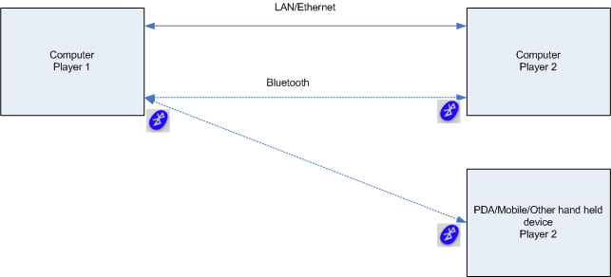
Figure 1 block diagram

Design 1:

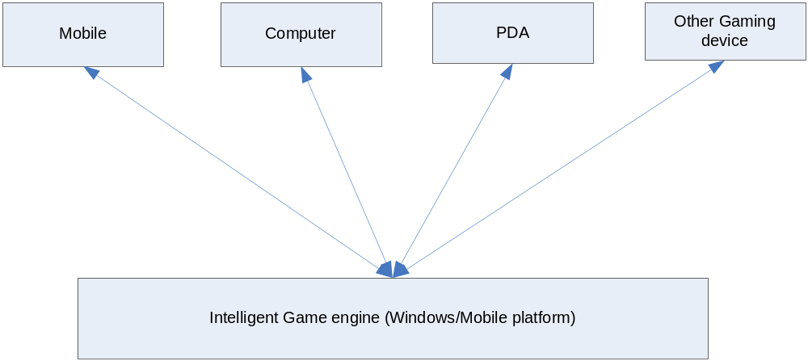
Figure 2 Design method 1

Design 2:
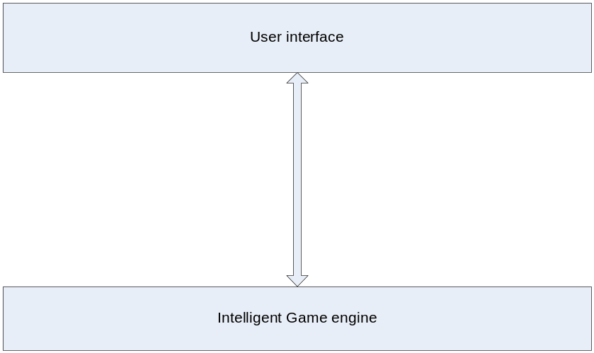
Figure 3 Design method 2

The game engine can be selected from any available market engines
- Html
- Java 3d
- Panda 3d
- Unity
- Ios
- Real engine

Design 3:

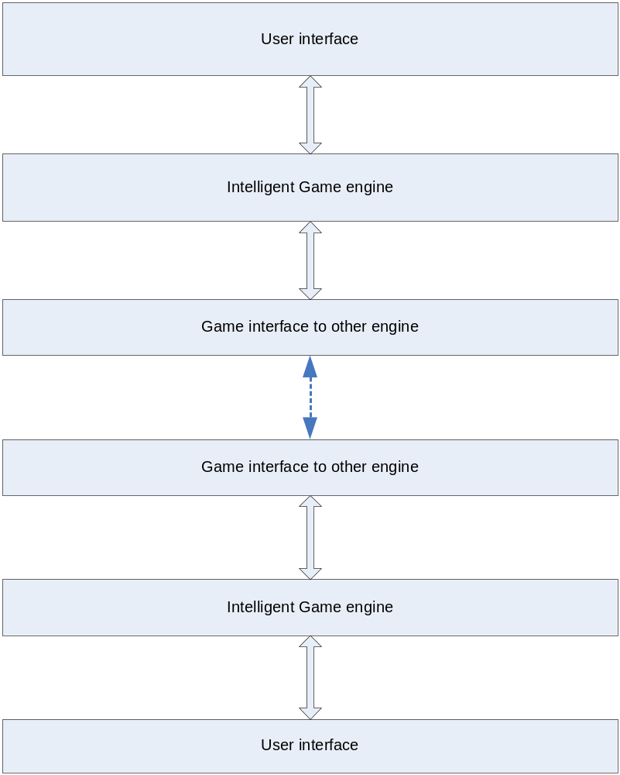
Figure 4 Design method 3

Game Rules:

Move:
It will have 15 sheep and 3 wolf coins
Default 3 wolf will be available. For every move the 15 sheep’s has to be deployed.

Layout:
The layout will look as shown in figure below.

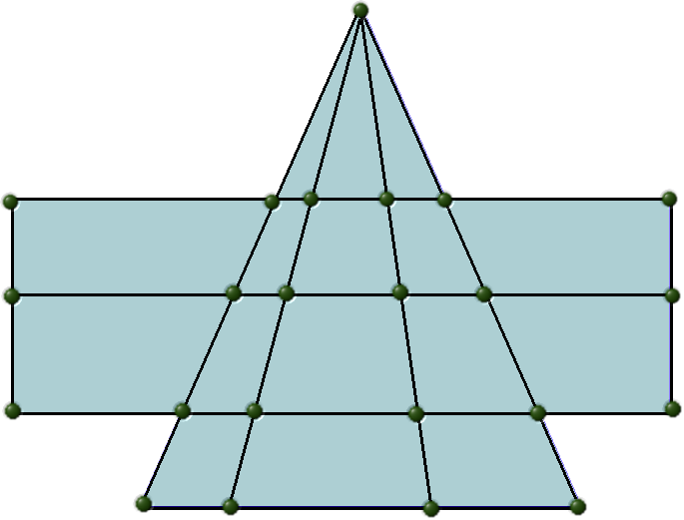
Figure 5 game layout

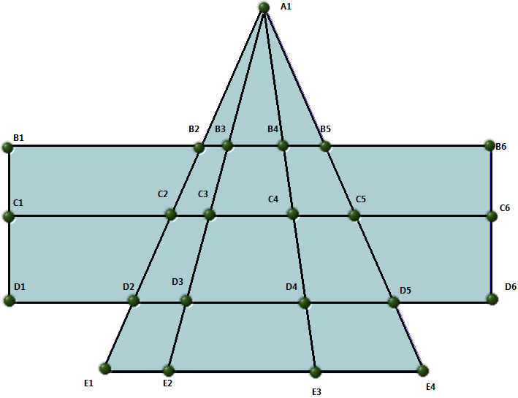
Figure 6 layout reference
Description:
The wolf coins will have the three coins placed in A1, B3, B4.
If the wolf faces sheep with out support it will eat that sheep and move to next.
The sheep’s and wolf moves in the junction point of triangle. All coins shall move in all directions.
Sheep’s can be moved only after deploying all 15 coins.

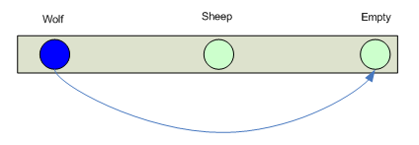
Figure 7 Cut position

Wolf coin strength:
It will form triangle where ever possible after placing the coin.
It will push the coins to the corner & bottom of the triangle.
Don’t cut sheep even you have the option some time. As it may lead to lock.
Single wolf can keep moving between two points to avoid sheep’s to come nearby

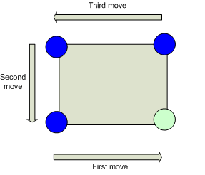
Figure 8 Square/karna move

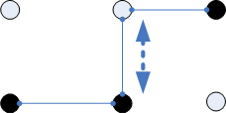
Figure 9 after karna move

Sheep coin strength:
Even you lose capture the top of triangle.
Save bottom by occupying the top rows.
Try to split the coin & lock it corner, So that the remaining sheep can be used for other’s sheep lock.

Difficulty level:
It shall be easy, medium, difficult levels depending upon the selection

Movement history shall be tracked and submitted if the user is win.
Pause/At work shall pause the timer

Time shall be tracked from the start of first coin to end of game.
The probability to win can be shown in status.
- if more than 3 sheep lost the wining probability is low.

Individual location shall indicate the following possible type
- Wolf
- Sheep
- Cut (animation)
- Empty

Design: This game can be designed with following configuration

- Network share two players
- Wolf coin by computer Sheep coin by user
- Wolf coin by user sheep coin side by computer
- Demo

Additional features:
- Licensing option
- Online account
- Data base option
- Online option
- Network game through LAN,WirelessLAN,Bluetooth
- Individual licence
- It shall be ported to mobile,ipad,mac and all Operating systems ,hardware
- Volume while cut of sheep, lock of wolf’s.

Information, statistics shall be displayed.

Practice:
Random 3 wolf’s and 13 to 15 sheep’s can be deployed for practice.

Research required:
Why 15 and 3 coins?
Why not 10 & 2 ,6 & 1?

Design:

Interface:
Depends upon the platform the game is developed / ported the game shall be interface with Ethernet communication, Server data base, Network.

Outcome:
The game shall be developed in very small size (kilo byte) based on game engine.

Game engine design:
The game engine shall be developed with available market tools so that it can not be viewable, usable for development of third party user.

Log:
The game movement, Player details shall be logged local/Server.

Communication protocol:
The following data will be exchanged in the network for the game between two players.

GAMERID | COINTYPE | POSITION
1-99 | 0/1 | (0,0) to (5,5) or 1 to 21

Game operation design:

- Game start
- Detect network peer
- Linking/paring
- Get first player input
- Publish on network with ID & lock till the second player’s turn
- Get second player input &publish on network with ID. Release the control for first player turn

The current player shall be highlighted & beep tone shall be generated if the time exceeds TBD seconds.

The game shall be developed for the following platforms
- Windows
- MAC
- PDA
- Game instruments
- Mobile platform

The following modules
- Game engine

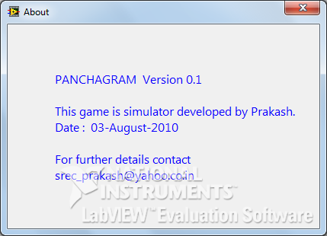
Figure 10 Splash screen

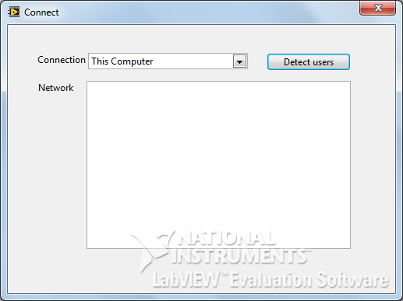
Figure 11 Game interface

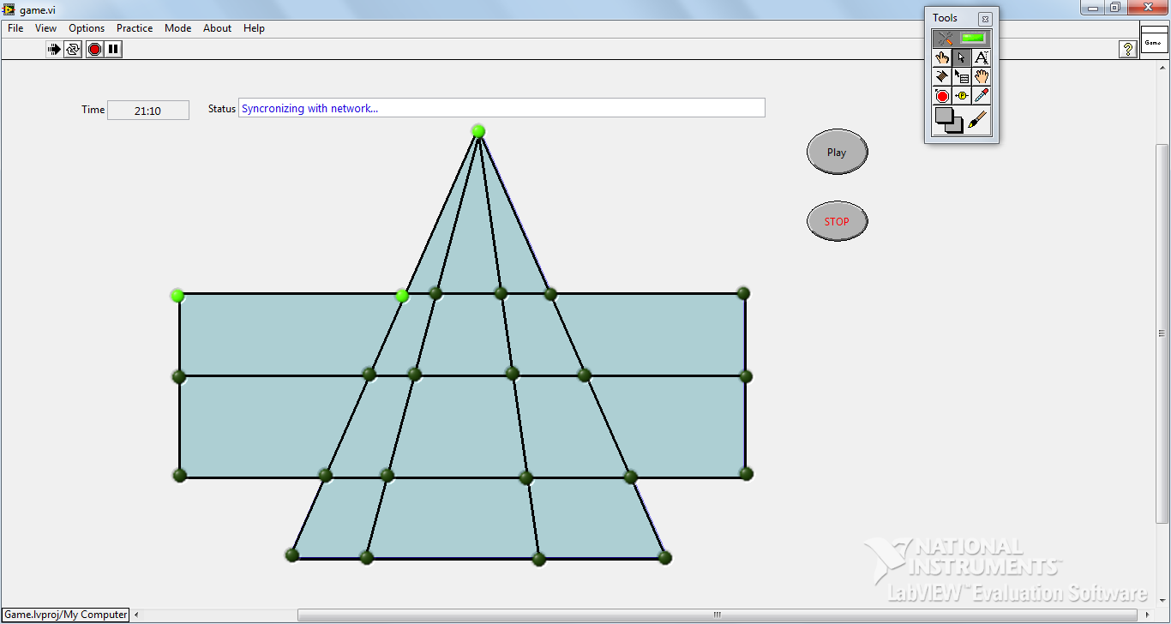
Figure 12 Main screen

Prototype

http://youtu.be/DXfR6lCKbCg

Reference:
- Chess game from www.chessbin.com
- Video’s captured during the game with two Players
- http://youtu.be/DXfR6lCKbCg

- Game Simulator application

